

Statistics for Computer Science

Assignment Guidelines
Read the following instructions carefully before you start the assignment. If you do not understand any of them, ask your lecturer.
- The assignment coversheet should be the first sheet in your assignment. Moreover, the coversheet should be fully completed with all the necessary details.
- This is a time-constrained assignment. The total time allowed for this assignment is 1.5 hours.
- Copying is strictly prohibited and will be penalized in line with the College’s disciplinary procedures.
- This is an open-book assignment.
- You may bring any electronic devices, pen-drives and/or books with you.
- No internet access is allowed except for the use of VLE and searches for material. No communication or sharing of information is allowed.
- All work that has been carried out must be written down and included within the assignment as evidence. No marks will be awarded for work that is not presented.

Scenario

An Excel file with data has been provided to you by your lecturer via the VLE. The Excel file contains two data sets:
- Data Set 1, contains data to be used in Section 1 of the assignment (Linear Regression). A scatter plot of Data Set 1 is presented in figure 1.
- Data Set 2, contains data to be used in Section 2 for the KS-test.

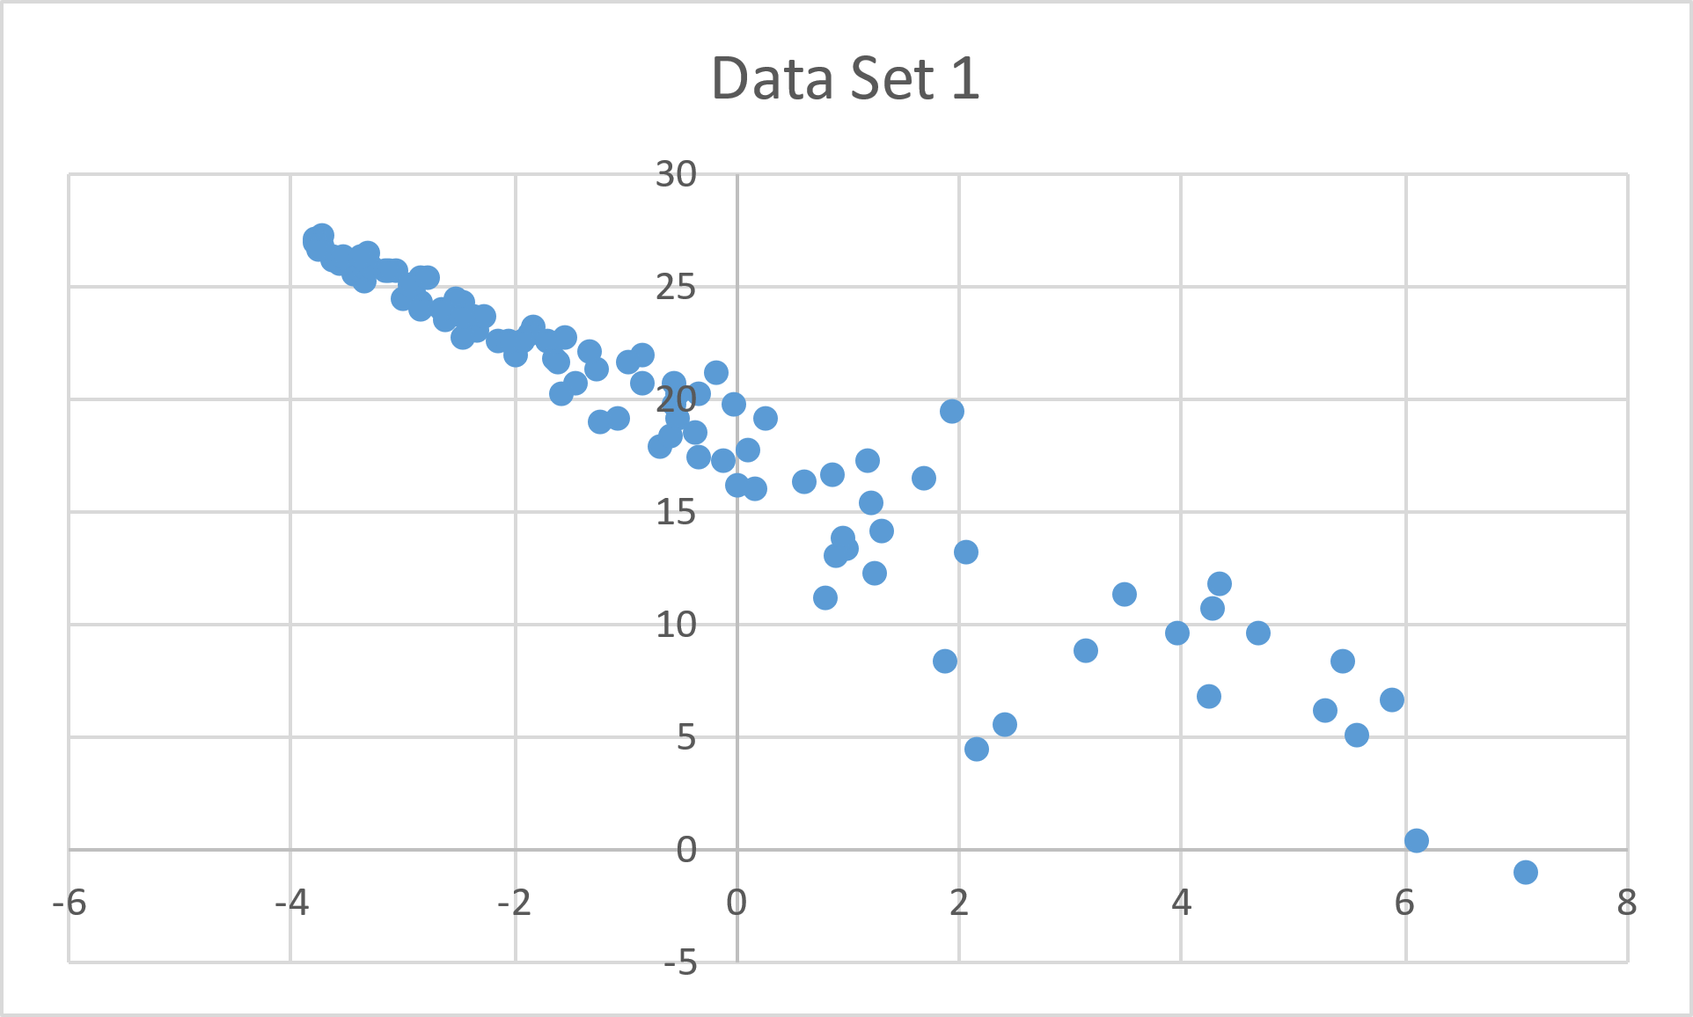
Figure 1 – A scatter plot of the Data set.

Section 1
Linear Regression (19 marks)

Task 1 (KU2.2, 5 marks)

Describe 3 assumptions of linear regression (3 marks).
- Linearity: The relationship between the independent and dependent variables are assumed to be linear.
- Normality: All variables must be multivariate normal.
- Multicollinearity: It is assumed that the amount of correlation between independent variables is not high.

Describe one assumption of linear regression that is not met in Data Set 1 (2 marks).
Variables in the range of (-4, 27) and (-2,22) show high correlation with each other, indicating multicollinearity.

Task 2 (AA2.3, 7 marks)

Using Ordinary Least Squares Linear Regression, find the line of best fit for Data Set 1. Write down the line of best fit found in the space below (5 marks). Remember to submit your working.
(Done in Excel) =LINEST(A2:A101, B2:B101, TRUE, TRUE)
Y = −0.38755x + 6.923017
Provide the $R^{2}$ of the fit obtained (2 marks).
0.91730793

Task 3 (AA2.4, 7 marks)

Interpret the meaning of the following values of $R^{2}$ for results of linear regression. Some of the $R^{2}$ values below may be invalid, in which case, please state that the value is invalid. In the other cases, please explain whether the $R^{2}$ value indicates a strong fit (1 mark each):

$R^{2}=-0.8$
Negative value, therefore awful fit

$R^{2}=0.2$
Only 20% of the variable is explained, therefore a weak fit

$R^{2}=0.75$
75% of variable is explained, therefore moderately strong fit

$R^{2}=1.2$
Range exceeded 1, therefore invalid

Interpret also the $R^{2}$ result obtained in Task 2. Does the value indicate a strong fit (1 mark)? Discuss the validity of the result obtained in the linear regression from Task 2 (2 marks).
$R^{2} result from Task 2 is a very strong fit indicated by the value of 0.92 \left(rounded\right), meaning$ $that 92\% of the variability is explained by the independent variables. Since this value is very$ close to 1, it suggests a strong fit. There was no additional analysis added on to this result, such as residual analysis or checks for overfitting. Therefore, there is a chance that the values might be invalid.

Section 2
KS-test (10 marks)

Task 4 (KU2.1, 5 marks)

A KS-test will be carried out on Data Set 2 against the normal distribution with $μ=0$ and $σ^{2}=10$, in other words, $N(0 , 10)$ with alpha = 0.05.

Find the critical value for the test to be carried out (3 marks).
Dα = (1.36/√50) = (1.36/7.071) = 0.1923
Define the null and alternate hypothesis for this KS test (2 marks).
Null Hypothesis: The data follows a normal distribution with $μ=0$ and $σ^{2}=10, i.e., X \sim N(0 , 10)$
Alternate Hypothesis: The data does not follow a normal distribution $N(0 , 10)$

Task 5 (KU1.3, 5 marks)

Carry out a KS-test on Data Set 2 against the normal distribution with $μ=0$ and $σ^{2}=10$, in other words, $N(0 , 10)$ and provide an appropriate conclusion for a significance level alpha = 0.05 (5 marks). Remember to submit your working.
Dn ​= 14.6667
Dα = (1.36/√50) = (1.36/7.071) = 0.1923
Since 14.6667 is much greater than 0.1923, the null hypothesis is rejected. At α=0.05, the KS-Test provides strong evidence that Data Set 2 does not follow a normal distribution.

Section 3
Concepts and Definitions. (5 marks)

Task 6 (KU1.1, 5 marks)

Answer the quiz for KU1.1 on the VLE (5 marks).
KU1.1: https://vle.mcast.edu.mt/mod/quiz/view.php?id=23792

